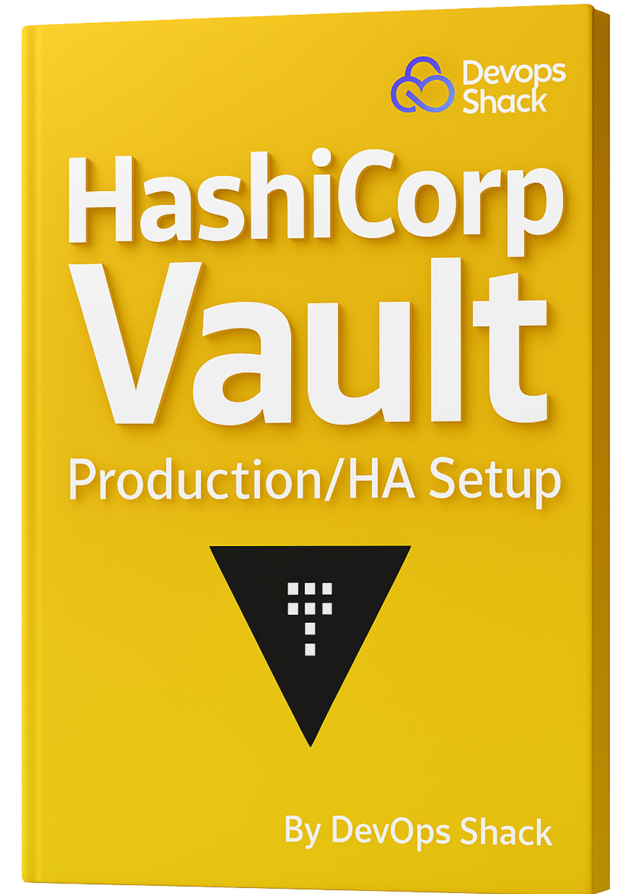

Complete HashiCorp Vault Setup On EKS
Steps To Setup EKS
Repo To use is attached in module.
# Install AWS CLI
curl "https://awscli.amazonaws.com/awscli-exe-linux-x86_64.zip" -o "awscliv2.zip"
sudo apt install unzip
unzip awscliv2.zip
sudo ./aws/install
aws configure
-------------------------------------------------------------------------------------
#Install Terraform
sudo apt-get update && sudo apt-get install -y gnupg software-properties-common curl

curl -fsSL https://apt.releases.hashicorp.com/gpg | sudo gpg --dearmor -o /usr/share/keyrings/hashicorp-archive-keyring.gpg

echo "deb [signed-by=/usr/share/keyrings/hashicorp-archive-keyring.gpg] https://apt.releases.hashicorp.com $(lsb_release -cs) main" | sudo tee /etc/apt/sources.list.d/hashicorp.list

sudo apt-get update && sudo apt-get install terraform -y

terraform -version
-------------------------------------------------------------------------------------------
# Install EKS Using Terraform
terraform init
terraform apply –auto-approve
# Kubeconfig
aws eks --region ap-south-1 update-kubeconfig --name devopsshack-cluster
---------------------------------------------------------------------------------
# Kubectl
curl -LO "https://dl.k8s.io/release/$(curl -L -s https://dl.k8s.io/release/stable.txt)/bin/linux/amd64/kubectl"

curl -LO "https://dl.k8s.io/release/$(curl -L -s https://dl.k8s.io/release/stable.txt)/bin/linux/amd64/kubectl.sha256"

sudo install -o root -g root -m 0755 kubectl /usr/local/bin/kubectl

kubectl version --client
------------------------------------------------------------------------------------------
# EKSCTL
curl -sLO "https://github.com/weaveworks/eksctl/releases/latest/download/eksctl_$(uname -s)_amd64.tar.gz"

tar -xzf eksctl_$(uname -s)_amd64.tar.gz

sudo mv eksctl /usr/local/bin

eksctl version

-------------------------------------------------------------------------------------------
#Install HELM
sudo apt update && sudo apt upgrade -y
curl https://raw.githubusercontent.com/helm/helm/main/scripts/get-helm-3 | bash

If above commands didn’t work; run below set of commands:

wget https://get.helm.sh/helm-v3.14.0-linux-amd64.tar.gz
tar -zxvf helm-v3.14.0-linux-amd64.tar.gz
sudo mv linux-amd64/helm /usr/local/bin/helm
helm version
==================================================================================
eksctl utils associate-iam-oidc-provider --region ap-south-1 --cluster devopsshack-cluster --approve
-----------------------------------------------------------------------------------------------
eksctl create iamserviceaccount \
--region ap-south-1 \
--name ebs-csi-controller-sa \
--namespace kube-system \
--cluster devopsshack-cluster \
--attach-policy-arn arn:aws:iam::aws:policy/service-role/AmazonEBSCSIDriverPolicy \
--approve \
--override-existing-serviceaccounts
-----------------------------------------------------------------------------------------------
kubectl apply -k "github.com/kubernetes-sigs/aws-ebs-csi-driver/deploy/kubernetes/overlays/stable/ecr/?ref=release-1.11"

kubectl apply -f https://raw.githubusercontent.com/kubernetes/ingress-nginx/main/deploy/static/provider/cloud/deploy.yaml

kubectl apply -f https://github.com/cert-manager/cert-manager/releases/download/v1.12.0/cert-manager.yaml
HashiCorp Vault Steps
✅ STEP 1: Create Namespace for Vault
kubectl create namespace vault
🧠 Why?
To separate Vault’s workloads from the rest of your cluster for organization and RBAC control.

✅ STEP 2: Add Helm Repo and Install Vault with Raft HA
helm repo add hashicorp https://helm.releases.hashicorp.com
helm repo update
Create vault-values.yaml for Production:
server:
ha:
enabled: true
replicas: 3
raft:
enabled: true
config: |
ui = true

listener "tcp" {
address = "0.0.0.0:8200"
cluster_address = "0.0.0.0:8201"
tls_disable = 1
}

storage "raft" {
path = "/vault/data"

retry_join {
leader_api_addr = "http://vault-0.vault-internal:8200"
}
retry_join {
leader_api_addr = "http://vault-1.vault-internal:8200"
}
retry_join {
leader_api_addr = "http://vault-2.vault-internal:8200"
}
}

service_registration "kubernetes" {}

dataStorage:
enabled: true
size: 10Gi
storageClass: "gp2" # or "ebs-sc" if you've defined your own

extraEnvironmentVars:
VAULT_LOG_LEVEL: "debug"

injector:
enabled: true

ui:
enabled: true

Install Vault with this config:
helm install vault hashicorp/vault -n vault -f vault-values.yaml

✅ STEP 3: Expose Vault Using LoadBalancer
Create a service vault-service.yaml:
apiVersion: v1
kind: Service
metadata:
name: vault
namespace: vault
spec:
type: LoadBalancer
ports:
- port: 8200
targetPort: 8200
selector:
app.kubernetes.io/name: vault

Apply it:
kubectl apply -f vault-service.yaml

✅ STEP 4: Initialize Vault (Run Once)
kubectl exec -n vault -it vault-0 -- vault operator init
☝️ Copy and save:
- 5 unseal keys
- 1 initial root token

✅ STEP 5: Unseal Vault on All Pods
Use any 3 keys on each Vault pod:

kubectl exec -n vault -it vault-0 -- vault operator unseal <key>
kubectl exec -n vault -it vault-1 -- vault operator unseal <key>
kubectl exec -n vault -it vault-2 -- vault operator unseal <key>

✅ STEP 6: Login to Vault
kubectl exec -n vault -it vault-0 -- vault login <root-token>

✅ STEP 7: Enable Kubernetes Authentication
kubectl exec -n vault -it vault-0 -- vault auth enable kubernetes

✅ STEP 8: Create Service Account for App Pods
kubectl create namespace webapps
kubectl create serviceaccount vault-auth -n webapps

✅ STEP 9: Configure Kubernetes Auth in Vault
Extract required info:
SERVICE_ACCOUNT_NAME=vault-auth
NAMESPACE=webapps

# JWT Token
TOKEN_REVIEW_JWT=$(kubectl get secret $(kubectl get serviceaccount $SERVICE_ACCOUNT_NAME -n $NAMESPACE -o jsonpath="{.secrets[0].name}") -n $NAMESPACE -o jsonpath="{.data.token}" | base64 --decode)

# Kubernetes API Host
KUBE_HOST=$(kubectl config view --raw -o=jsonpath='{.clusters[0].cluster.server}')

# Kubernetes CA Cert
KUBE_CA_CERT=$(kubectl get secret $(kubectl get serviceaccount $SERVICE_ACCOUNT_NAME -n $NAMESPACE -o jsonpath="{.secrets[0].name}") -n $NAMESPACE -o jsonpath="{.data['ca.crt']}" | base64 --decode)

Configure in Vault:
kubectl exec -n vault -it vault-0 -- vault write auth/kubernetes/config \
token_reviewer_jwt="$TOKEN_REVIEW_JWT" \
kubernetes_host="$KUBE_HOST" \
kubernetes_ca_cert="$KUBE_CA_CERT"

✅ STEP 10: Create Vault Policy
Create a file myapp-policy.hcl:
# Access to read/write secret data
path "secret/data/mysql" {
capabilities = ["create", "update", "read", "delete", "list"]
}

path "secret/data/frontend" {
capabilities = ["create", "update", "read", "delete", "list"]
}

# Access to list secrets under the path
path "secret/metadata/mysql" {
capabilities = ["list"]
}

path "secret/metadata/frontend" {
capabilities = ["list"]
}
Upload and apply:
kubectl cp myapp-policy.hcl vault/vault-0:/tmp/myapp-policy.hcl
kubectl exec -n vault -it vault-0 -- vault policy write myapp-policy /tmp/myapp-policy.hcl

✅ STEP 11: Create Role in Vault to Map Pod to Policy
kubectl exec -n vault -it vault-0 -- vault write auth/kubernetes/role/vault-role \
bound_service_account_names=vault-auth \
bound_service_account_namespaces="webapps" \
policies=myapp-policy \
ttl=24h

✅ STEP 12: Store Secrets in Vault
# Enable KV V2 Engine
kubectl exec -n vault -it vault-0 -- vault secrets enable -path=secret -version=2 kv
# Store Secrets in Vault
kubectl exec -n vault -it vault-0 -- vault kv put secret/mysql MYSQL_DATABASE=bankappdb MYSQL_ROOT_PASSWORD=Test@123
kubectl exec -n vault -it vault-0 -- vault kv put secret/frontend MYSQL_ROOT_PASSWORD=Test@123

✅ STEP 13: Create YAML Manifest File (With Below Configurations)
Example annotation block for a pod:
annotations:
vault.hashicorp.com/agent-inject: "true"
vault.hashicorp.com/role: "vault-role"
vault.hashicorp.com/agent-inject-secret-MYSQL_ROOT_PASSWORD: "secret/mysql"
vault.hashicorp.com/agent-inject-template-MYSQL_ROOT_PASSWORD: |
{{- with secret "secret/mysql" -}}
export MYSQL_ROOT_PASSWORD="{{ .Data.data.MYSQL_ROOT_PASSWORD }}"
{{- end }}
The sidecar Vault Agent will:
- Auth using the service account token
- Fetch secrets from Vault
- Write them to /vault/secrets/... inside the pod

✅ STEP 13: Final YAML Manifest File
---
# Create the namespace for our applications
apiVersion: v1
kind: Namespace
metadata:
name: webapps
---
# Create a Service Account for Vault authentication
apiVersion: v1
kind: ServiceAccount
metadata:
name: vault-auth
namespace: webapps
---
# StorageClass for AWS EBS (ensure your cluster supports this provisioner)
apiVersion: storage.k8s.io/v1
kind: StorageClass
metadata:
name: ebs-sc
provisioner: ebs.csi.aws.com
parameters:
type: gp3
fsType: ext4
reclaimPolicy: Retain
volumeBindingMode: WaitForFirstConsumer
---
# PersistentVolumeClaim for MySQL data
apiVersion: v1
kind: PersistentVolumeClaim
metadata:
name: mysql-pvc
namespace: webapps
spec:
accessModes:
- ReadWriteOnce
resources:
requests:
storage: 5Gi
storageClassName: ebs-sc
---
# MySQL Deployment with Vault KV v2 Injection
apiVersion: apps/v1
kind: Deployment
metadata:
name: mysql
namespace: webapps
spec:
selector:
matchLabels:
app: mysql
strategy:
type: Recreate
template:
metadata:
labels:
app: mysql
annotations:
vault.hashicorp.com/agent-inject: "true"
vault.hashicorp.com/agent-inject-secret-MYSQL_ROOT_PASSWORD: "secret/data/mysql"
vault.hashicorp.com/agent-inject-template-MYSQL_ROOT_PASSWORD: |
{{- with secret "secret/data/mysql" -}}
export MYSQL_ROOT_PASSWORD="{{ .Data.data.MYSQL_ROOT_PASSWORD }}"
{{- end }}
vault.hashicorp.com/agent-inject-secret-MYSQL_DATABASE: "secret/data/mysql"
vault.hashicorp.com/agent-inject-template-MYSQL_DATABASE: |
{{- with secret "secret/data/mysql" -}}
export MYSQL_DATABASE="{{ .Data.data.MYSQL_DATABASE }}"
{{- end }}
vault.hashicorp.com/role: "vault-role"
spec:
serviceAccountName: vault-auth
containers:
- name: mysql
image: mysql:8
command: ["/bin/sh", "-c"]
args:
- "while [ ! -s /vault/secrets/mysql_root_password ]; do echo 'Waiting for Vault secrets...'; sleep 2; done; \
chmod 600 /vault/secrets/mysql_root_password; \
chmod 600 /vault/secrets/mysql_database; \
source /vault/secrets/mysql_root_password; \
source /vault/secrets/mysql_database; \
export MYSQL_ROOT_PASSWORD=$MYSQL_ROOT_PASSWORD; \
export MYSQL_DATABASE=$MYSQL_DATABASE; \
echo 'Secrets Loaded: MYSQL_ROOT_PASSWORD=' $MYSQL_ROOT_PASSWORD 'MYSQL_DATABASE=' $MYSQL_DATABASE; \
exec docker-entrypoint.sh mysqld"
ports:
- containerPort: 3306
name: mysql
volumeMounts:
- mountPath: /var/lib/mysql
name: mysql-data
livenessProbe:
exec:
command: ["mysqladmin", "ping", "-h", "127.0.0.1"]
initialDelaySeconds: 30
periodSeconds: 10
failureThreshold: 5
readinessProbe:
exec:
command: ["mysqladmin", "ping", "-h", "127.0.0.1"]
initialDelaySeconds: 30
periodSeconds: 10
failureThreshold: 5
volumes:
- name: mysql-data
persistentVolumeClaim:
claimName: mysql-pvc
---
# MySQL Service
apiVersion: v1
kind: Service
metadata:
name: mysql-service
namespace: webapps
spec:
ports:
- port: 3306
targetPort: 3306
selector:
app: mysql
---
# BankApp Deployment with Vault KV v2 Injection
apiVersion: apps/v1
kind: Deployment
metadata:
name: bankapp
namespace: webapps
spec:
replicas: 1
selector:
matchLabels:
app: bankapp
template:
metadata:
labels:
app: bankapp
annotations:
vault.hashicorp.com/agent-inject: "true"
vault.hashicorp.com/role: "vault-role"
vault.hashicorp.com/agent-inject-secret-SPRING_DATASOURCE_PASSWORD: "secret/data/frontend"
vault.hashicorp.com/agent-inject-template-SPRING_DATASOURCE_PASSWORD: |
{{- with secret "secret/data/frontend" -}}
export SPRING_DATASOURCE_PASSWORD="{{ .Data.data.MYSQL_ROOT_PASSWORD }}"
{{- end }}
spec:
serviceAccountName: vault-auth
containers:
- name: bankapp
image: adijaiswal/bankapp:v20
ports:
- containerPort: 8080
env:
- name: SPRING_DATASOURCE_URL
value: "jdbc:mysql://mysql-service:3306/bankappdb?useSSL=false&serverTimezone=UTC&allowPublicKeyRetrieval=true"
- name: SPRING_DATASOURCE_USERNAME
value: "root"
livenessProbe:
httpGet:
path: /login
port: 8080
initialDelaySeconds: 30
timeoutSeconds: 5
periodSeconds: 10
failureThreshold: 5
readinessProbe:
httpGet:
path: /login
port: 8080
initialDelaySeconds: 30
timeoutSeconds: 5
periodSeconds: 10
failureThreshold: 5
---
# BankApp Service
apiVersion: v1
kind: Service
metadata:
name: bankapp-service
namespace: webapps
spec:
type: LoadBalancer
ports:
- port: 80
targetPort: 8080
selector:
app: bankapp

✅ STEP 13: Final YAML Manifest File
Apply the manifest
kubectl apply -f manifest.yaml -n webapps

Deployed Application:
